Trig ch 2 notes
2.1 Degrees and Radians: Page 63#1-3,5-35odds,41-57odds,59,61,65.
Radian Measure of Central Angles

Ex1: What is radian measure of an angle of 180°?

Degrees: 180°

Radian – Degree Conversion Formulas:
Ex2 a) Find the degree measure of 1 rad in exact form and in decimal form to 4 decimal places.

Ex2 b) Find the radian measure of -120° in exact form and in decimal form to 4 places.

Ex2 c) Use TI to do parts a & b.
Notice how TI can only get decimal form, not exact form.
Ex3 Sketch angles in their standard positions
- 120° b) $\frac{−π}{6}\text{rad}$ c) $\frac{−7p}{2}\text{rad}$ d)-495°

Coterminal angles have coinciding terminal sides. The degree measures of 2 coterminal angles differ by an integer multiple of 360 degrees. The radian measures of 2 coterminal angles differ by an integer multiple of 2π.

Ex4: Which pairs of angles are coterminal?
$$\begin{aligned}a)α=\text{60}°,β=\text{420}° \\ b)α=\frac{7p}{4}\text{rad},β\text{=-}\frac{p}{4}\text{rad} \\ c)α=\text{90}°,β\text{=-}\text{90}° \\ d)α\text{=-}\frac{p}{6}\text{rad},β\text{=-}\frac{\text{25}p}{6}\text{rad}\end{aligned}$$

It’s much easier to find arc length in radians than degrees.
Ex5: In a circle of radius 6.00 ft, find the arc length subtended by a central angle of: a) 1.70 rad b) 40.0°.

$\frac{A_{\text{sec}\text{tor}}}{{pr}^{2}}=\frac{q}{\text{360}°}⇒A_{\text{sec}\text{tor}}=\frac{p}{\text{360}°}r^{2}q$ when $q$ is in degrees
$\frac{A_{\text{sec}\text{tor}}}{{pr}^{2}}=\frac{q}{2p}⇒A_{\text{sec}\text{tor}}=\frac{1}{2}r^{2}q$ when $q$ is in radians

Ex6: In a circle of radius 7 in, find the area (4 sig. figures) of sector with central angle:
a) 0.1332 rad
b) 110°
2.2 Linear and Angular Velocity: Page 71#3,7,9-11,15-25odds.
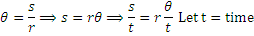
Let
Let w== angular velocity
V=rw and V=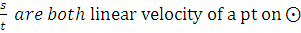
W= and w= are both angular velocity

Ex1 If a 3.0 ft diameter wheel turns at 12. What is the velocity of a pt on the wheel? (in )
Velocity of a pt. on the wheel is linear velocity V.

Ex2 A pt. on the rim of a 4.00 in. diameter wheel is traveling at . What is the angular velocity (in )?

Ex3 If an 8 cm diameter shaft in a boat is rotating at 350 rpm, what is speed of a particle on its surface (in to 3 sig figs)?

Ex4 The space shuttle Columbia was placed in a circular orbit 250 miles above Earth’s surface. One orbit is completed in 1.51 hr. If the radius of the Earth is 3964 miles, what is the linear velocity of the shuttle in (3 sig figs)?

2.3 Trig Functions: Page 82#19,21,41-93odds. Quiz on 2.1-2.3 and unit circle on Th.
Trig Functions with Angle Domains

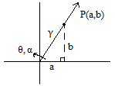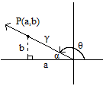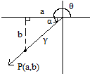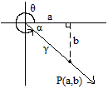

Sin = csc = ≠ csc = , b ≠ 0

Cos = sec = 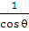 ≠ sec = , a ≠ 0
Tan = cot = ≠ cot = , b ≠ 0
r² = a² + b² r = > 0

Ex1 Find the exact value of 6 trig functions if the terminal side contains:
a) (-8,-6) b) (-4,-3) c) (-12,-9) d) Patterns

Ex2 find the exact value of the other 5 trig functions (without finding ) given that terminal sides of is in quadrant II and tan = .

Trig Functions with Real # X Domains
Sin X = sin (X rad) Csc X = csc (X rad)
Cos X = cos (X rad) Sec X = sec (X rad)
Tan X = tan (X rad) Cot X = cot (X rad)
Ex3 Evaluate to 4 significant figures with a calculator:
- Cos 303.73 =

- Sec (-2.805) =

- Tan (-83 =

- Sin (12 rad) =

- Csc 100°52’43” =

- Cot 9 =

Ex4 A wind generator can generate current: I = 50 cos(120where
t= time in seconds and I= current in amperes. What is the current (2 decimal places) when t= 1.09 seconds?

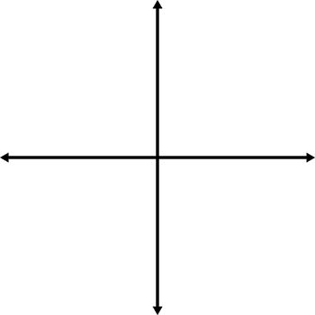
Pos Neg.
Sin, csc cos, sec,
tan, cot

Pos Neg.
sin, csc none
cos, sec,
tan, cot

Pos Neg.
Tan, cot cos, sec,
Sin, csc
Pos Neg.
Cos, sec sin, csc
tan, cot

All Students Take Calculus
I II III IV

__________ In class: do worksheet #37, 19, 14 and how to memorize unit circle; Hwk: Review, page 118#1,2,4-10,18,19,25, 29-32,50,60,72,74.
_________ 2.3Quiz, including unit circle.
2.5 Exact Value for special Angles and Real Numbers
2.5 day 1. Page 110 #1-41 odds. Unit circle quiz (10 points each).
2.5 day 2. Page 110#10-42 evens,43-75odds,81. Unit circle quiz (10 points each).
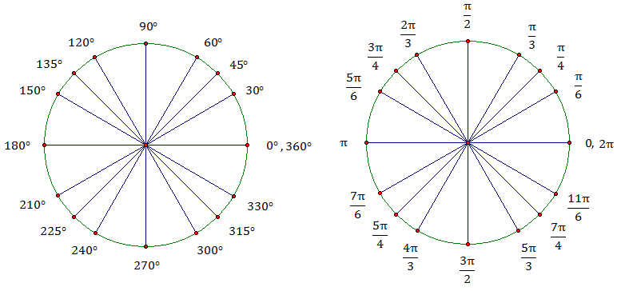
Memorize:

10 pts quiz tomorrow: get 3 minutes to fill in
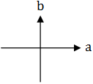
Think of x, y axes as a, b axes:

Reference triangle and angle
1. Reference triangle: drop a from P(a, b) on the terminal side of to the horizontal axis.
2. Reference angle : acute, positive between the terminal side of and the horizontal axis.
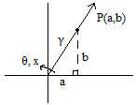

Ex1 Find: a) b)$\text{sec}(−π)$ c) d)

Ex2 Sketch the reference and the reference angle .
a)
b)
c)
d)

From geometry: 2 special types of right triangles
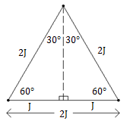
--rt : start with an equilateral of side 2J and drop an altitude:

Using Pythagorean Theorem:

Notice the shortest side J is opposite of smallest , medium side is opposite of medium ; longest side 2J is opposite of largest .
--rt (isosceles rt ):
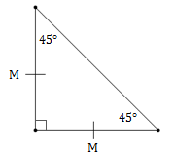
Using Pythagorean Theorem:

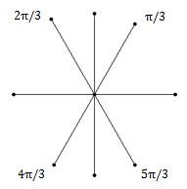
Multiples of or in :

Multiples of or in :
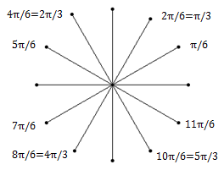

Multiples of or 45 in :
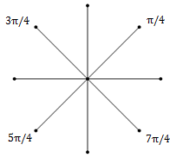
Ex3 Evaluate exactly:
a)
b)
c)
d)
e)
f)
g)
h)
i)
j)

Ex4 Find the least positive in degree and radian for which each is true.
a)
b)
Fill in after finding pattern:
 | 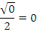
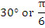 | 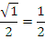
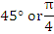
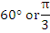
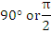 | 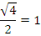
Sine and Cosine are complementary functions, so

Special Values Table: Memorize this!
 | 0 |  | 1 |  | 0
 |  |  |  |  | 1
 | 1 |  | 0

Def: A function f is periodic if there is a pos real number p st for all x in the domain of f. The smallest such p, if it exists, is called the period of f.
Sine and Cosine have period of.

Ex5 If , what is:
a)
b)
c)
d)
e)

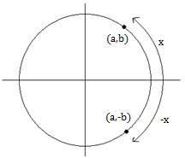

(Positive!)

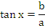
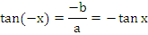
Sin and tan are odd functions since we have proven that Sin(-x)=-Sinx and Tan(-x)=-Tanx. Cos is an even function since we see above that Cos(-x)=Cosx.
Since is on the unit circle, then by Pyth Thm: ,
by substitution
simplify
commutative
Which is a trig identity.
Caution:

Ex6 Simplify by using trig definitions and identities.
a)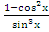
b)

