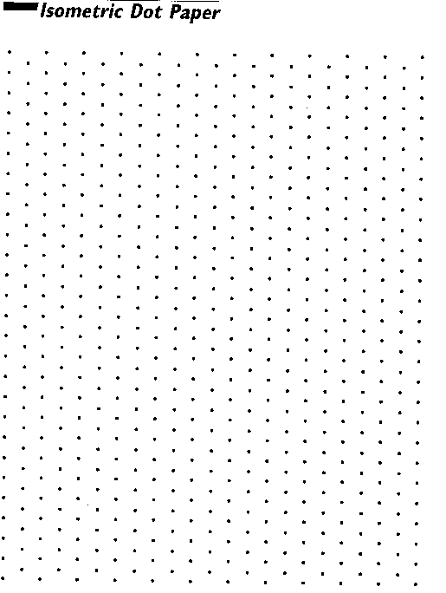
McDougal Geometry chapter 9 notes
9.1 Translate figures and use vectors, p 578 #33-42. Bring graph paper tomorrow and daily in ch9.
Read the top 2 paragraphs of page 572.
TK#83: Isometry: An isometry is a transformation that preserves length and angle measure (in other words, things stay congruent). Translation, reflection, and rotation are isometries.
Another way to describe a translation is by using a vector. A vector is a quantity that has both direction and magnitude, or size. A vector is represented in the coordinate plane by an arrow drawn from one point to another. See blue box on the top of page 574.
GP 2-7. (Use the back of this page if you need more room.)

9.2 Use properties of matrices, p 584 #9-12,17-24,33
Read the top 3 paragraphs for the definition of matrix on page 580. The dimension of a matrix is row by column.
To add or subtract matrices, the matrices must have the same dimensions.
Matrices can only be multiplied if the number of columns of the first matrix matches the number of rows of the second matrix. If matrix A has dimensions m by n and matrix B has dimensions n by p, then the AB has dimensions m by p and BA is not defined.
GP 1,2,4-8.
9.3 Perform reflections, p 593 #3-12,19-21 (on graph paper). Pass out 1 sheet of patty paper for GP 6.
Read the top 2 paragraphs on page 589.
TK#84: Coordinate rule for Reflections: If (a,b) is reflected in the x-axis, its image is (a,-b). If (a,b) is reflected in the y-axis, its image is (-a,b). If (a,b) is reflected in the line y=x, its image is (b,a). If (a,b) is reflected in the line y=-x, its image is (-b,-a).
TK#85: Reflection matrices: Reflection in the x-axis $\left[\begin{matrix}1 & 0 \\ 0 & −1\end{matrix}\right]$; Reflection in the y-axis $\left[\begin{matrix}−1 & 0 \\ 0 & 1\end{matrix}\right]$
GP 1-6.

9.4 Perform rotations, p 602 #3-5, 13-23 odds, 29-32 (on graph paper)
Read the top 3 paragraphs on page 598.
TK#86: Coordinate rulers for rotations about the origin: When a point (a,b) is rotated counterclockwise about the origin: 1. For a rotation of $\text{90}°:(a,b)→(−b,a)\text{.}$ 2. For a rotation of $\text{180}°:(a,b)→(−a,−b)\text{.}$ 3. For a rotation of $\text{270}°:(a,b)→(b,−a)\text{.}$
You can find certain images of a polygon rotated about the origin using matrix multiplication. Write the rotation matrix to the left of the polygon matrix, then multiply. See TK#87 for the rotation matrix used with 90⁰, 180⁰, 270⁰, and 360⁰.
TK#87: Rotation matrices (counterclockwise): 90⁰ rotation $\left[\begin{matrix}0 & −1 \\ 1 & 0\end{matrix}\right]$; 180⁰ rotation $\left[\begin{matrix}−1 & 0 \\ 0 & −1\end{matrix}\right]$;270⁰ rotation $\left[\begin{matrix}0 & 1 \\ −1 & 0\end{matrix}\right]$;360⁰ rotation $\left[\begin{matrix}1 & 0 \\ 0 & 1\end{matrix}\right]$

GP 2,6, 3-5.

9.5 Apply compositions of transformations, p 611 #3-21 odds, 28-33 (on graph paper)
Read about glide reflection at the top of page 608. Footsteps can be glide reflections.
TK#88: Composition Thm: The composition of 2 or more isometries is an isometry.
TK#89:Reflections in Parallel Lines Thm: If lines k and m are parallel, then a reflection in line k followed by a reflection in line m is the same as a translation. If P” is the image of P, then: 1. $\overline{\text{PP}\text{\}\} \} \{}}$is perpendicular to k and m, and 2. PP”=2d, where d is the distance between k and m.
TK#90: Reflections in Intersecting Lines Thm: If lines k and m intersect at point P, then a reflection in k followed by a reflection in m is the same as a rotation about point P. The angle of rotation is 2x⁰, where x⁰ is the measure of the acute angle formed by k and m.
GP 1-8 (skip 4)

9.6 Identify symmetry, p621#3-21 odds, 27,29. Bring compass and straightedge tomorrow.
Read the paragraph at the top of page 619 for the definition of the line of symmetry.
How many lines of symmetry does the photo of One To One have (ignore middle line of text)?
Do GP 2-4.
Read the top 3 paragraphs at the top of page 620 about rotational symmetry.
Do GP 5-8.
9.7 Identify and perform dilations, p.629#5-29 odds
A dilation is a transformation in which the original figure and its image are similar. A dilation with center C and scale factor k maps every point P in a figure to a point P’ so that one of the following statements is true:
If P is not the center point C, then the image of P’ lies on CP$\vec{\text{CP}}\text{.}$. The scale factor k is a positive number such that $k=\frac{\text{CP}'}{\text{CP}}$and k is not equal to 1, or
If P is the center point C, then P=P’. Recall from previously:
TK#57: Similarity transformation: With dilation: If 0<k<1, reduction. If k>1, enlargement.
GP1

Do example 2 with a scale factor of 5/2 using a compass and straightedge. Use the back of this page for more room.
GP4, GP 6.

Extension Tessellations, p 617 #1-18 (on graph paper). Pass out 3 sheets of patty paper.
Read the top two paragraphs on page 616 for the definition of tessellation.
Go through examples 1-3.

Watch and take notes on Escher video. Write down 3 facts you did NOT know about Escher. Write 3 other interesting facts.
Instead of taking a test this chapter, you will be creating 3 Escher-like tessellations by hand. The best one will be turned in for 100 points.
Translational tessellation: use parallelograms or regular hexagons
Rotational tessellation: use equilateral triangles or regular hexagons
Glide reflectional tessellation: use kites or parallelograms
Tessellation Evaluation ID# of artist:__________________________________
Period:______________Col#:___________________

Name of critic:________________________________________

Did the person:
- Use ID# and not have his/her name on it? 0 1 2
- Specify which of the 3 transformations correctly? 0 1 2
- Correctly state which original shape s/he started with? 0 1 2
- Include a step by step explanation with diagrams
of how the tessellation was created? 0 1 2
- Include the original patty paper template or index
card template of tessellation? 0 1
- Tessellate at least 15 times on the page/poster? 0 1 2
- Complete an entire page (at least 8” by 11”)? 0 1 2
- Include an appropriate title for her/his art? 0 1
- Originality/creativity 0 1 2
- Level of difficulty/complexity: 0 1 2
More cuts/moves=more complex
More intricate of a design/more detail=more complex
- Overall quality/aesthetics (title=art?) 0 1 2

Total: ____________/20

Name of critic:________________________________________

Did the person:
- Use ID# and not have his/her name on it? 0 1 2
- Specify which of the 3 transformations correctly? 0 1 2
- Correctly state which original shape s/he started with? 0 1 2
- Include a step by step explanation with diagrams
of how the tessellation was created? 0 1 2
- Include the original patty paper template or index
card template of tessellation? 0 1
- Tessellate at least 15 times on the page/poster? 0 1 2
- Complete an entire page (at least 8” by 11”)? 0 1 2
- Include an appropriate title for her/his art? 0 1
- Originality/creativity 0 1 2
- Level of difficulty/complexity: 0 1 2
More cuts/moves=more complex
More intricate of a design/more detail=more complex
- Overall quality/aesthetics (title=art?) 0 1 2

Total: ____________/20

Name of critic:________________________________________

Did the person:
- Use ID# and not have his/her name on it? 0 1 2
- Specify which of the 3 transformations correctly? 0 1 2
- Correctly state which original shape s/he started with? 0 1 2
- Include a step by step explanation with diagrams
of how the tessellation was created? 0 1 2
- Include the original patty paper template or index
card template of tessellation? 0 1
- Tessellate at least 15 times on the page/poster? 0 1 2
- Complete an entire page (at least 8” by 11”)? 0 1 2
- Include an appropriate title for her/his art? 0 1
- Originality/creativity 0 1 2
- Level of difficulty/complexity: 0 1 2
More cuts/moves=more complex
More intricate of a design/more detail=more complex
- Overall quality/aesthetics (title=art?) 0 1 2

Total: ____________/20

Name of critic:________________________________________

Did the person:
- Use ID# and not have his/her name on it? 0 1 2
- Specify which of the 3 transformations correctly? 0 1 2
- Correctly state which original shape s/he started with? 0 1 2
- Include a step by step explanation with diagrams
of how the tessellation was created? 0 1 2
- Include the original patty paper template or index
card template of tessellation? 0 1
- Tessellate at least 15 times on the page/poster? 0 1 2
- Complete an entire page (at least 8” by 11”)? 0 1 2
- Include an appropriate title for her/his art? 0 1
- Originality/creativity 0 1 2
- Level of difficulty/complexity: 0 1 2
More cuts/moves=more complex
More intricate of a design/more detail=more complex
- Overall quality/aesthetics (title=art?) 0 1 2

Total: ____________/20

Name of critic:________________________________________

Did the person:
- Use ID# and not have his/her name on it? 0 1 2
- Specify which of the 3 transformations correctly? 0 1 2
- Correctly state which original shape s/he started with? 0 1 2
- Include a step by step explanation with diagrams
of how the tessellation was created? 0 1 2
- Include the original patty paper template or index
card template of tessellation? 0 1
- Tessellate at least 15 times on the page/poster? 0 1 2
- Complete an entire page (at least 8” by 11”)? 0 1 2
- Include an appropriate title for her/his art? 0 1
- Originality/creativity 0 1 2
- Level of difficulty/complexity: 0 1 2
More cuts/moves=more complex
More intricate of a design/more detail=more complex
- Overall quality/aesthetics (title=art?) 0 1 2

Total: ____________/20

To the fifth critic: Please total the 5 scores here: _________________________/100

