7.1 Polar and rectangular coordinates, P407#5-27odds,43-59odds

Since cosθ=x/r and sinθ=y/r, then we can cross multiply to get:
x=rcosθ, y=rsinθ,
tanθ=y/x, r²=x²+y² are the formulas to convert between polar (r,θ) and rectangular (x,y) coordinates.

Ex 1 Plot on polar graph paper on the next page:
A(7,30◦), B(-6,165◦), C(-9,-90◦)$D\left(\text{10},\frac{π}{3}\right),E\left(8,−\frac{7π}{6}\right),F\left(−5,−\frac{5π}{4}\right)$

Ex 2 Change $A\left(8,\frac{π}{3}\right),B\left(−6,\frac{5π}{4}\right),F\left(−4,−\frac{7π}{6}\right)$ to exact rectangular coordinates.
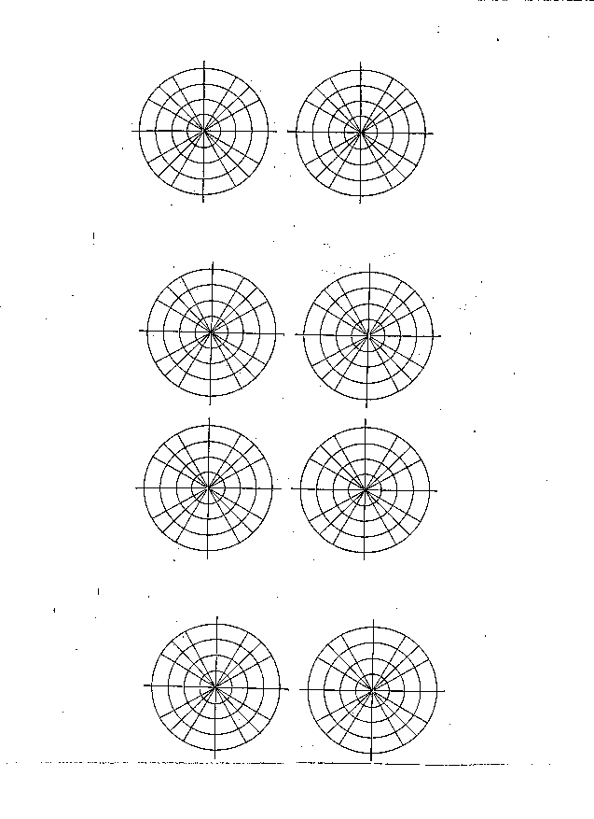
7.2 Polar graphs
Ex 3 Change $A(\sqrt{3},1)$ and $B(1,−\sqrt{3})$ to polar form with $r≥0$and $−π<θ<2π$.

Ex 4 Change $x^{2}+y^{2}−2y=0$ to polar form.

Ex 5 Change $r=−8\text{cos}θ$ to rectangular form.
7.2 day 1 hwk: Page 418#1,2,5-10. (Need 8 polar graphs.)
7.2 day 2 hwk. Page 418#11-20. (Need 10 polar graphs.)

Look at table 3 on page 415 for 12 common polar graphs and their equations. Graph examples 1-4 on the polar graphs on the next page. Don’t forget to label and scale the axes.

Ex1: Graph $r=3q,0≤q≤\frac{7p}{6}$in a polar coordinate system by using point-by-point plotting ($q$ in radians).

Ex2: Graph $r=4\text{sin}q$ ($q$ in radians).

Ex3: Graph $r=4+4\text{cos}q$ ($q$ in radians).

Ex4: Graph $r=2\text{cos}3q$ ($q$ in radians).
7.3, The Complex Plane, Page 428#1-25odds (skip part c on 9-15odds.)

Def: The absolute value of the complex number z=a+bi is: $|a+\text{bi}|=\sqrt{a^{2}+b^{2}}$.
The trig form of the complex number z=a+bi is: z=r(cosθ+isinθ) where a=rcosθ, b=rsinθ, $r=\sqrt{a^{2}+b^{2}}$, and $\text{tan}θ=\frac{b}{a}$. r is the modulus of z, and θ is an argument of z. The polar form is $z={\text{re}}^{iθ}$.

Ex1: Plot each number in a complex plane. Use the polar graphs on the next page.
A) $4e^{i\left(\frac{−p}{6}\right)}$ B) -4-3i C) $5e^{i\left(\frac{p}{2}\right)}$ D) 4

Ex2: Write the following in polar form ($q$ in radians, $−p≤q≤p$). Compute the modulus and argument exactly.
- z₁=1-i B)$z_{2}\text{=-}\sqrt{3}+i$

Ex3: Write the following in rectangular form. Compute the exact values.
A) $z_{1}=2e^{\left(\frac{5p}{6}\right)i}$ B) $z_{2}=3e^{\left(−\text{60}°\right)i}$

Let z₁=r₁(cosθ₁+isinθ₁) and z₂=r₂(cosθ₂+isinθ₂) be two complex numbers.
Product: z₁z₂=r₁r₂ [cos(θ₁+θ₂)+isin((θ₁+θ₂)]
Quotient: $\frac{z_{1}}{z_{2}}=\frac{r_{1}}{r_{2}}[\text{cos}(θ_{1}−θ_{2})+i\text{sin}(θ_{1}−θ_{2})]$
To multiply 2 complex numbers, we multiply the 2 moduli (r) and add the 2 arguments (θ). To divide 2 complex numbers, we divide the 2 moduli and subtract the 2 arguments.
If time: prove the formula for the product of two complex numbers.

Ex4: If $z_{1}=\text{21}e^{\left(\text{140}°\right)i}$ and $z_{2}=3e^{\left(\text{105}°\right)i}$ , find:
A) z₁z₂ B) $\frac{z_{1}}{z_{2}}$

__________ 7.3. Page 428#1-25odds (skip part c on 9-15odds.)
__________ Review: page 440#1-10,12-18,21-24.
__________ Chapter 7 group quiz. Hwk: Cumulative review chapters 1-7 day 1 (need graph and polar graph paper). Page 441#1-6,9,10,14-18,20-38.
__________ Correct chapter 7 group quiz.
__________ Chapter 7 test. Hwk: Cumulative review chapters 1-7 day 2 (need graph and polar graph paper). Page 442#44-54,67,69,78-80.
__________ Final exam will cover: 1.1-1.4, 2.1-2.6 (skip 2.4),3.1-3.6 (skip 3.4),4.1-4.4 (skip 4.5), skip chapter 5, 6.1-6.6,7.1-7.3 (skip 7.4) and SBAC questions. You will be allowed one 3 by 5 note card and no calculator of any kind. Practice final exam ch 1-3#1-30. Do NOT write on this! Scientific calculator allowed on practice only.
__________ Practice final exam ch 4,6,7#51-77. Do NOT write on this! Scientific calculator allowed on practice only.
__________ Final exam part 1: 19 multiple choice questions (NO calculator). Choose every answer that is true.
__________ Final Exam part 2: 16 multiple choice questions (NO calculator). Choose every answer that is true.

